NAME:Rishik JK
REG.NO :192511052

CSA1702-ARTIFICIAL INTELLIGENCE
LAB EXPERIMENT

- Write the python program to implement Feed forward neural Network

Aim
.To write a Python program to implement a Feed Forward Neural Network using input, hidden and output layers

Algorithm
- Start the program.
- Import the math library.
- Define the sigmoid activation function.
- Initialize the input values, weights and biases.
- Calculate the weighted sum of inputs in the hidden layer.
- Apply the sigmoid activation function to hidden neurons.
- Pass the hidden layer outputs to the output layer.
- Calculate the final output using the sigmoid function.
- Display the hidden layer and final output values.
- Stop the program
OUTPUT:
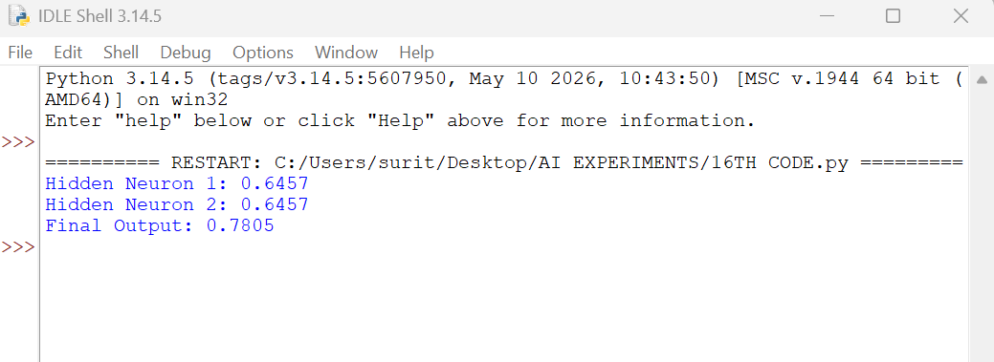
RESULT: Thus, the Python program to implement a Feed Forward Neural Network was successfully executed, and the final output was calculated using the sigmoid activation function.

